User Manual

Technical requirements
- 1.8 GHz or faster 64-bit processor, Quad-core or better.
- Minimum of 4 GB of RAM. 8 GB of RAM recommended
- Hard disk space: Minimum of 20 GB. (This includes the space required for Visual studio)
- Video card that supports a minimum display resolution of WXGA (1366 by 768);

Getting the system installed and launched
- Download and install Visual Studio with the following Workloads (If Visual Studio is already installed with the correct workloads skip to step 2):
  - Azure development
  - .NET desktop Development
  - Universal Windows Platform development
  - Data storage and processing

Clone repository

Open ‘grp3PROJECT.sln’ in Visual Studio

Attach/restore Spaza_DB in SQL Server

Update connection string in DBConfig.cs

Run it

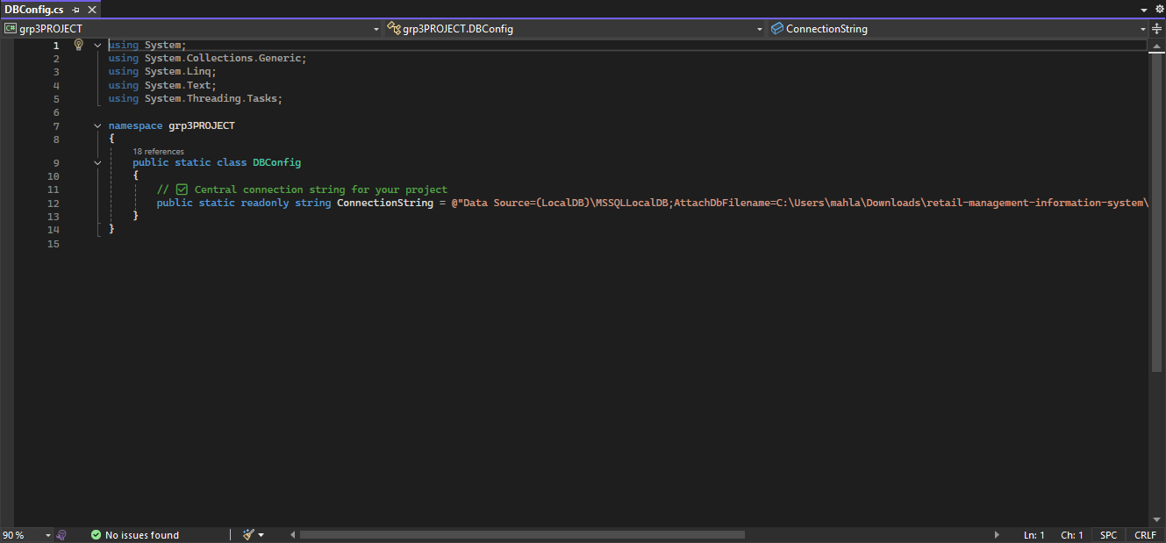
This the ‘DBConfig.cs’ class where you Update connection string(@”Data Source….30”)

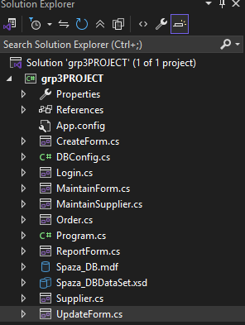
This is my ‘Solution Explore’ named ‘grp3PROJECT’
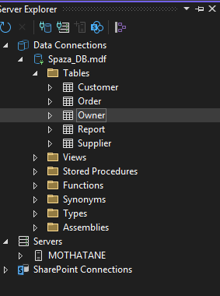
This is Sever Explorer where my database file ‘Spaza_DB.mdf’ is located

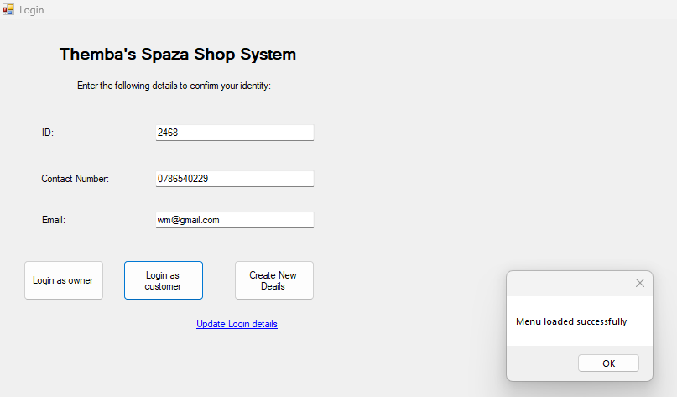
This is one of customers’ login credentials. The are stored under ‘Customer’ table inside the database file.

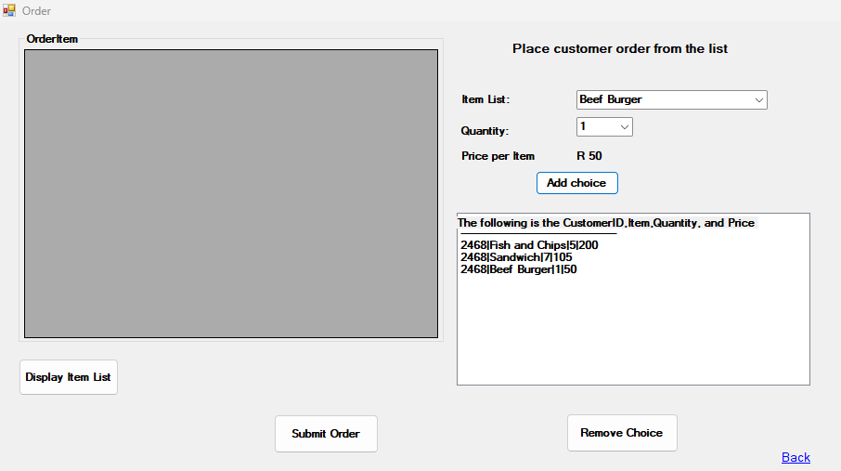
After Customer is successfully logged in, this form will show; where Customer add their orders the bag(ListBox) using ‘Add Choice’ button and they can also remove an order per line before submitting the order by selecting the order and clicking ‘Remove Choice’

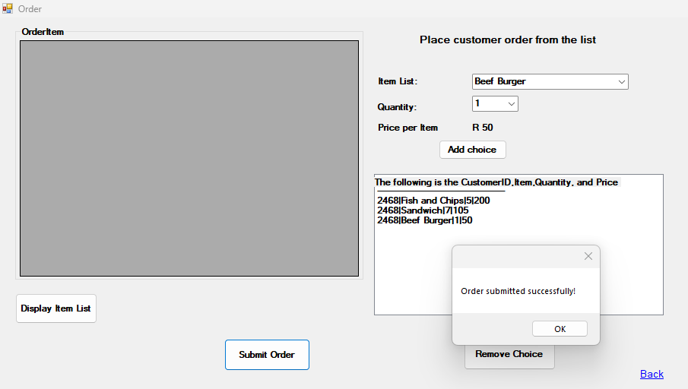
After the orders are added to the bag and confirmed, ‘Submit Order’ button is clicked to store the orders under ‘Order’ table.
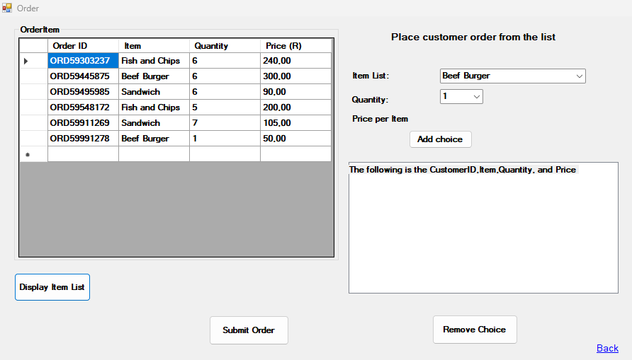
Customer can their own orders’ information by clicking ‘Display item List’ button. Only the orders that correspond to the ‘CustomerID’ that logged in are displayed to maintain customer information confidentiality

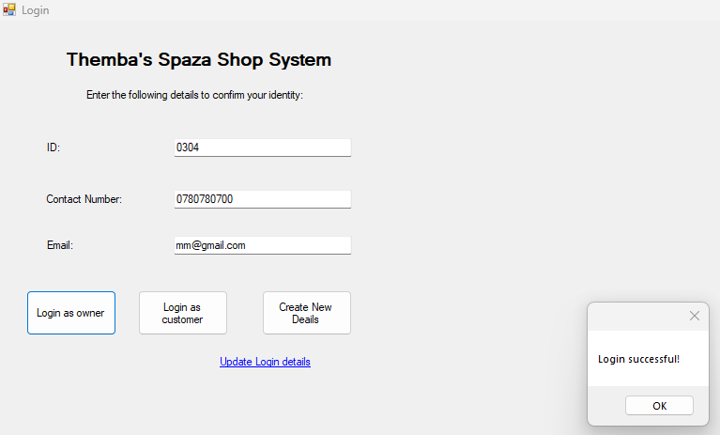
This is one of owners’ login credentials. The are stored under ‘Owner’ table inside the database file.
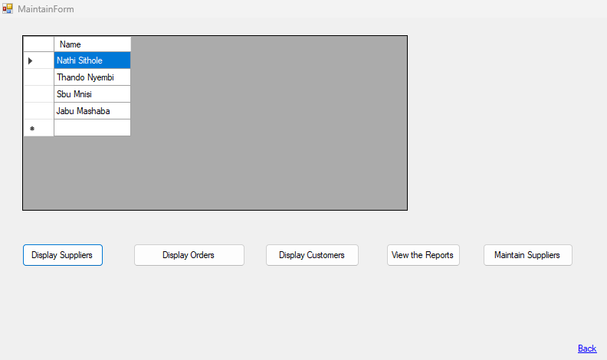
Owners can view their suppliers but only their names

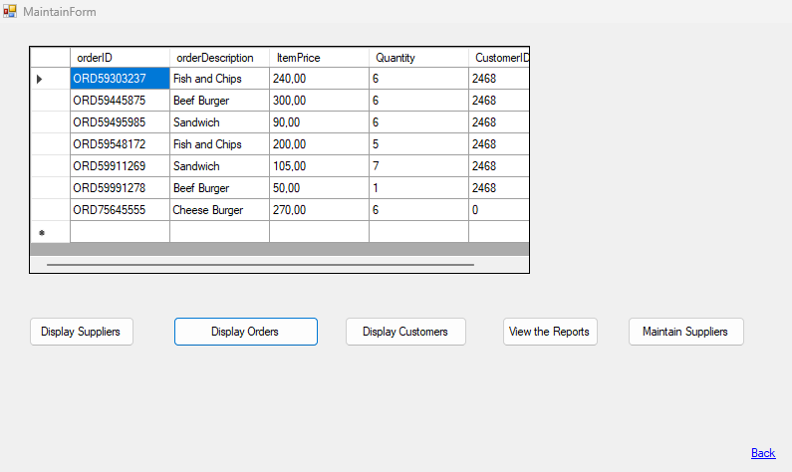
Owners can view the customers’ order information
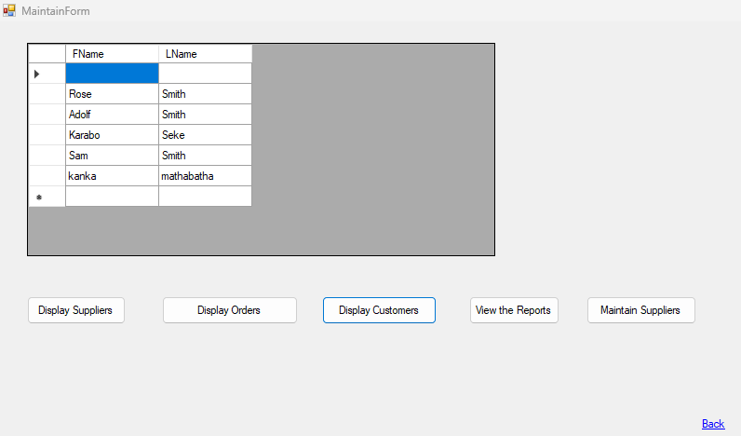
Owner can view their customers’ information but only their names. Owners can view also access the stock reports by clicking ‘View the Reports’
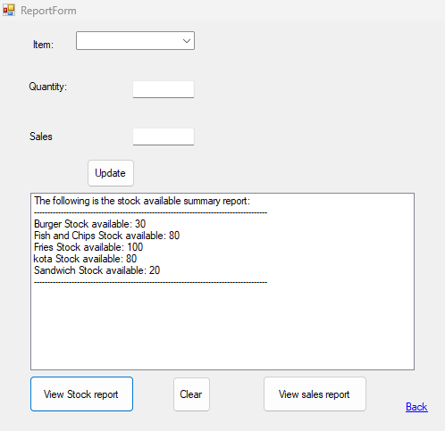
This form show when the owner clicks ‘View the Reports’ button. In this form, owner can view the stock available.

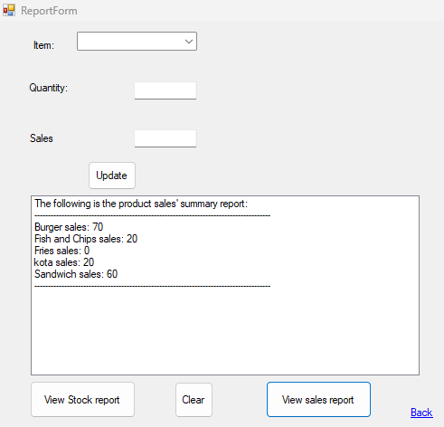
Owner can also view the stock sold.
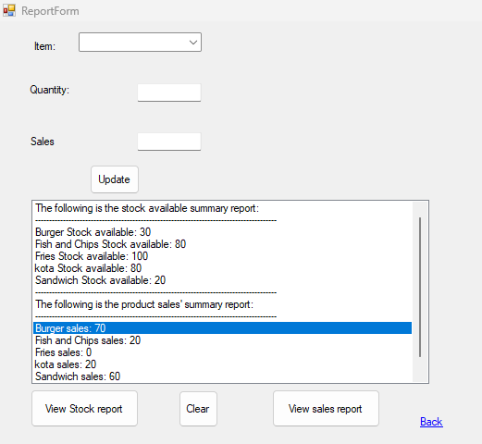
Owner can also update the stock reports. This is the stock reports before updating it.
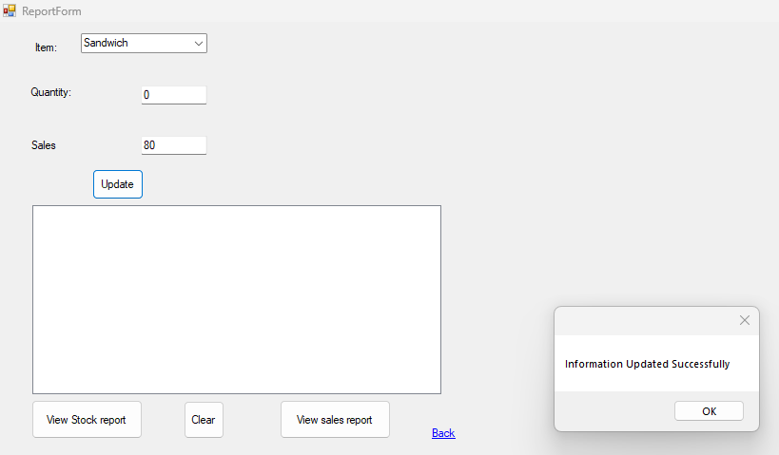
Owner updates the stock reports per item. ‘Quantity’ is the stock available, and ‘Sales’ is the stock sold
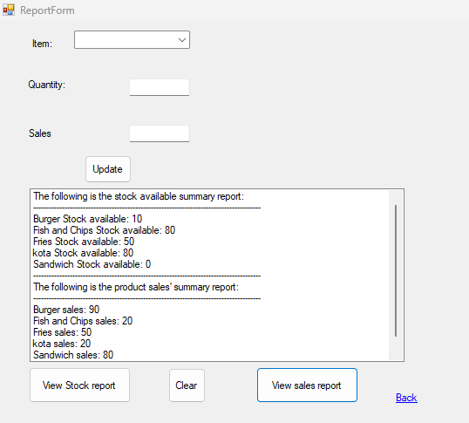
This is the stock reports after the updates.


Owners can also view and maintain suppliers details by clicking ‘Maintain Supplies’ button which will direct to ‘Supplier’ form
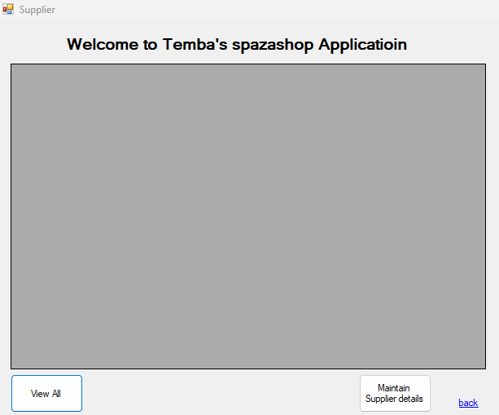
In this form owner can view suppliers. When ‘Maintain Suppliers details’ it will direct to ‘MaintainSupplier’ form.
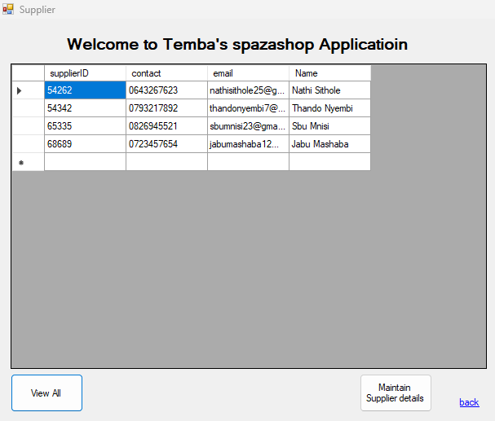
In this form, owner can view all information about each of the suppliers
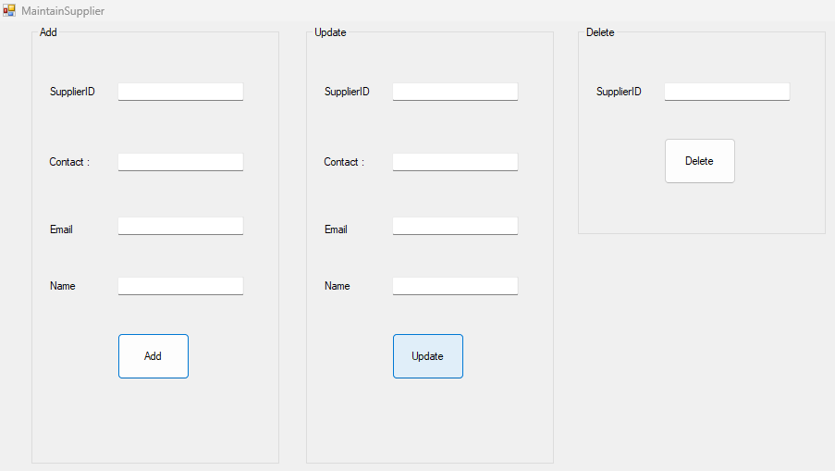
This is the form that shows when ‘Maintain Suppliers details’ button is clicked from previous form ‘Supplier’. In this form owner can add, update and/or Delete suppliers’ details.


When ‘Create New Details’ button is clicked it’ll direct to ‘CreateForm’ where both customers and owners can create their accounts.When ‘Update Login details' linklabel is clicked it’ll direct to ‘UpdateForm’ form where both customer and user can update their details.
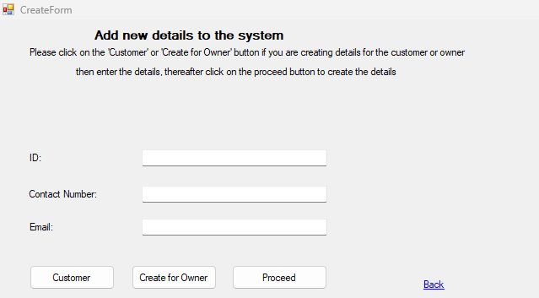
This is where both owner and customer can create their own accounts.

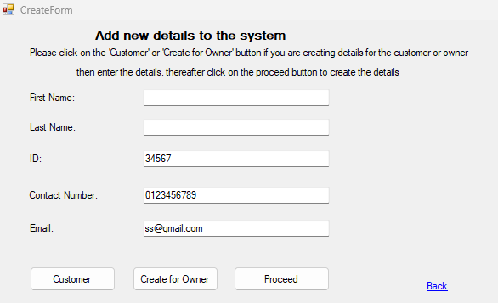
Follow the instructions on the top part of the form.
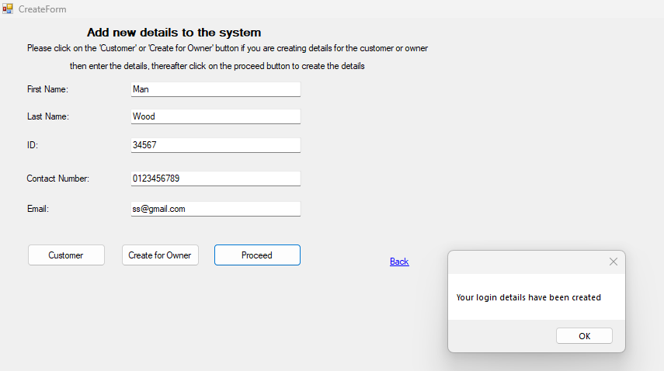
Account is successfully created.

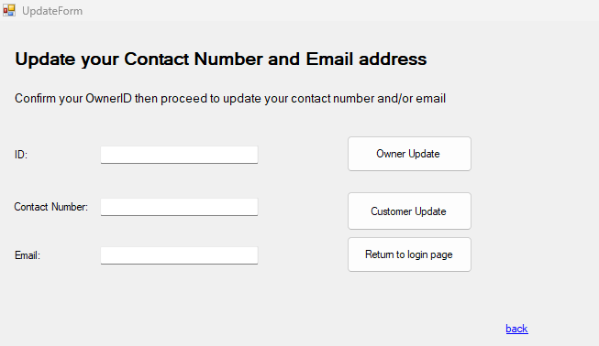
This is the ‘UpdateForm’ form where both owners and customers can update their login credentials.
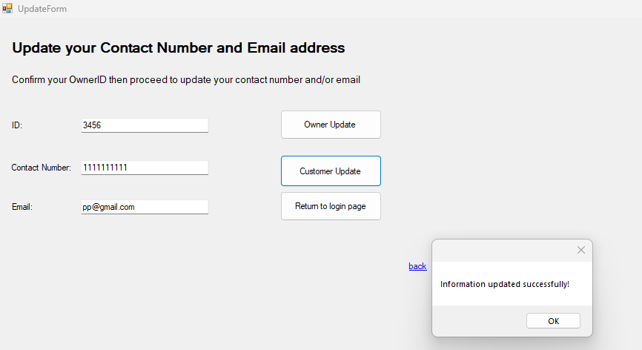
Login credentials are successfully updated

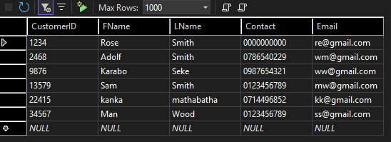
Customer table
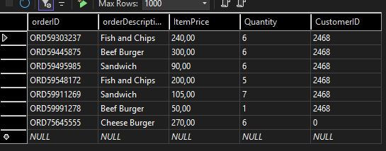
Order table

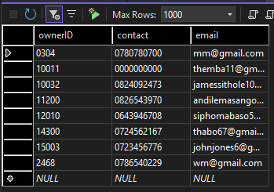
Owner table

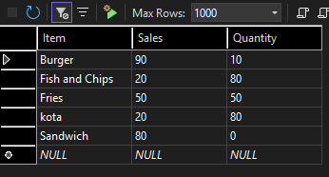
Report table
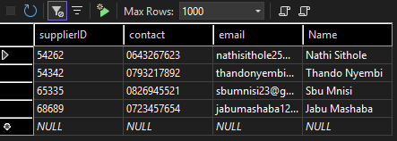
Supplier table

